**Name: Pradyumna P S**

**Email ID : pradyumnaps193@gmail.com**

**Topics: Descriptive Statistics and Probability**

1. Look at the data given below. Plot the data, find the outliers and find out $μ, σ, σ^{2}$

|  |  |
| --- | --- |
| **Name of company** | **Measure X** |
| Allied Signal | 24.23% |
| Bankers Trust | 25.53% |
| General Mills | 25.41% |
| ITT Industries | 24.14% |
| J.P.Morgan & Co. | 29.62% |
| Lehman Brothers | 28.25% |
| Marriott | 25.81% |
| MCI | 24.39% |
| Merrill Lynch | 40.26% |
| Microsoft | 32.95% |
| Morgan Stanley | 91.36% |
| Sun Microsystems | 25.99% |
| Travelers | 39.42% |
| US Airways | 26.71% |
| Warner-Lambert | 35.00% |

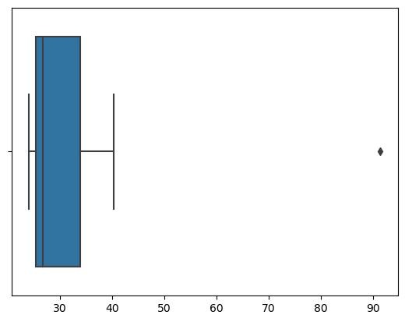

**Mean:** 33.27133333333333

**Standard Deviation:** 16.945400921222028

**Variance:** 287.146612380952

Also attached a python note book.



Answer the following three questions based on the box-plot above.

1. What is inter-quartile range of this dataset? ( Please approximate the numbers) In one line, explain what this value implies.

**IQR = 7**

**Inter Quartile Value is the difference between Q3 and Q1, which indicates 50% of the data .**

1. What can we say about the skewness of this dataset?

**As the right whisker is longer than the left whisker, we can say it as a right**

**Skewed plot. The mean is greater than the median.**

1. If it was found that the data point with the value 25 is actually 2.5, how would the new box-plot be affected?

**There will not be an outlier value, as the value 2.5 will come inside the whisker.**

**Whether the median shifts or not depends on the size of the data.**

**It will reduce the right skewness of the data.**



Answer the following three questions based on the histogram above.

1. Where would the mode of this dataset lie?

**Between 8 and 9 (approx.)**

1. Comment on the skewness of the dataset.

**As it is a right skewed plot, skewness will be positive.**

1. Suppose that the above histogram and the box-plot in question 2 are plotted for the same dataset. Explain how these graphs complement each other in providing information about any dataset.

**From the above histogram and barplot we can confirm an outlier at 25 in Y value. Both the plots indicate the +ve skewness of the dataset.**



| | | | |

Min Q1 M Q3 Max

| | | | |



1. AT&T was running commercials in 1990 aimed at luring back customers who had switched to one of the other long-distance phone service providers. One such commercial shows a businessman trying to reach Phoenix and mistakenly getting Fiji, where a half-naked native on a beach responds incomprehensibly in Polynesian. When asked about this advertisement, AT&T admitted that the portrayed incident did not actually take place but added that this was an enactment of something that “could happen.” Suppose that one in 200 long-distance telephone calls is misdirected. What is the probability that at least one in five attempted telephone calls reaches the wrong number? (Assume independence of attempts.)

**Ans) let us consider the probability of 1 call misdirected out of 200 as event A.**

**Probability of occurring of event A= 1/200**

**P(A)= 1/200**

**Probability of having at least one successful call will be**

**1-P(A)= 1-1/200= 199/200= 0.967**

**As every event is independent of other event the probability will be**

**1- (0.967)^5**

**0.02475 = 2% chance.**

1. Returns on a certain business venture, to the nearest $1,000, are known to follow the following probability distribution

|  |  |
| --- | --- |
| x | P(x) |
| -2,000 | 0.1 |
| -1,000 | 0.1 |
| 0 | 0.2 |
| 1000 | 0.2 |
| 2000 | 0.3 |
| 3000 | 0.1 |

1. What is the most likely monetary outcome of the business venture?

**Ans) The most likely outcome of this business venture is a return of $2000 as it has the highest probability of occurrence.**

1. Is the venture likely to be successful? Explain

**Ans) success of the venture can be defined in multiple ways. But based on the data provided, we can look at positive returns as a measure of success.**

**The probability distribution gives us an idea about the long-term chances of earning given values of returns (indicated by x). therefore, there is a 60% probability that the venture would be successful. (Note: 0.2+0.3+0.1=0.6=>0.6*100=>60%).**

1. What is the long-term average earning of business ventures of this kind? Explain

**Ans) From the above question requirement we have to consider similar business ventures of this type whose distribution of the returns is similar to this venture. In that case we say that the expected value of returns to this particular venture is the required average.**

**(-2000*0.1)+(-1000*0.1)+(0*0.2)+(1000*0.2)+**

**(2000*0.3)+(3000*0.1)=800**

**Therefore the long-term average earning for these type of ventures would be around $800.**

1. What is the good measure of the risk involved in a venture of this kind? Compute this measure

**Ans) Risk stems from the possible variability in the expected returns. Therefore a good measure to evaluate the risk for a venture of this kind would be variance or standard deviation of the variable X.**

**Standard deviation- 1870.829**

**Variance-3500000**

**The large value of standard deviation of $1870 is considered along with the average returns of $800 indicates that this venture is highly risky.**